Anantha Lakshmi Institute of Technology and Sciences (ALITS)
Department of Data Science

Visualizing Housing Market Trends: An Analysis of Sale Prices and Features using Tableau
Final Project Report
Submitted in partial fulfilment of the requirements of the Data Science program

Project Name: Housing Market Trends using Tableau
Team ID: ALITS-DS-2026-HousingMarketTrends
Academic Year: 2026

Certificate
This is to certify that the project report entitled "Visualizing Housing Market Trends: An Analysis of Sale Prices and Features using Tableau" is a bona fide record of work carried out by C Bhavani and team (Dinakar Akula, A Divet Kumar, Nagam Naga Swarna, Usha Sri Nama) of the Department of Data Science, Anantha Lakshmi Institute of Technology and Sciences (ALITS), during the academic year 2026.

Project Mentor Head of Department

Acknowledgement
We would like to express our sincere gratitude to our mentors and faculty at Anantha Lakshmi Institute of Technology and Sciences (ALITS) for their continuous guidance throughout this project.

Table of Contents
1. Introduction
2. Problem Statement
3. Proposed Solution
4. Dataset Description
5. System Architecture
6. Implementation & Actual Dashboard Output
7. Testing
8. Results & Discussion
9. Conclusion
10. Future Scope
11. References

1. Introduction
This project uses Tableau to transform the Transformed_Housing_Data_2.csv dataset (21,609 records) into an interactive dashboard that helps home buyers and analysts understand housing sale price trends and the impact of features such as house age, renovation status, bedrooms, bathrooms, and floors.
2. Problem Statement
Home buyers and real-estate analysts lack a single, interactive tool to explore how sale price relates to property age, renovation history, and structural features, relying instead on static spreadsheets or fragmented listing data.
3. Proposed Solution
An interactive Tableau dashboard suite (Sheet 1–4, Dashboard 1, Story 1) built directly on the cleaned housing dataset, requiring no programming — all logic is implemented via Tableau's native calculated fields, filters, and Measure Names/Values.
4. Dataset Description
The dataset Transformed_Housing_Data_2.csv contains 21,609 records and 30 columns, including Sale_Price, No of Bedrooms, No of Bathrooms, Flat/Lot Area, No of Floors, Age of House (in Years), Years Since Renovation, Ever_Renovated_Yes, Waterfront_View_Yes, and one-hot encoded Zipcode Group and Condition of the House fields.
Metric | Value
Total Records | 21,609
Total Fields | 30
Total Sale Price (sum) | 11,055,565,423
Total Area of House from Basement (sum) | 38,643,798
Records Ever Renovated = Yes (sample sum) | 204 (per current filter context)

5. System Architecture
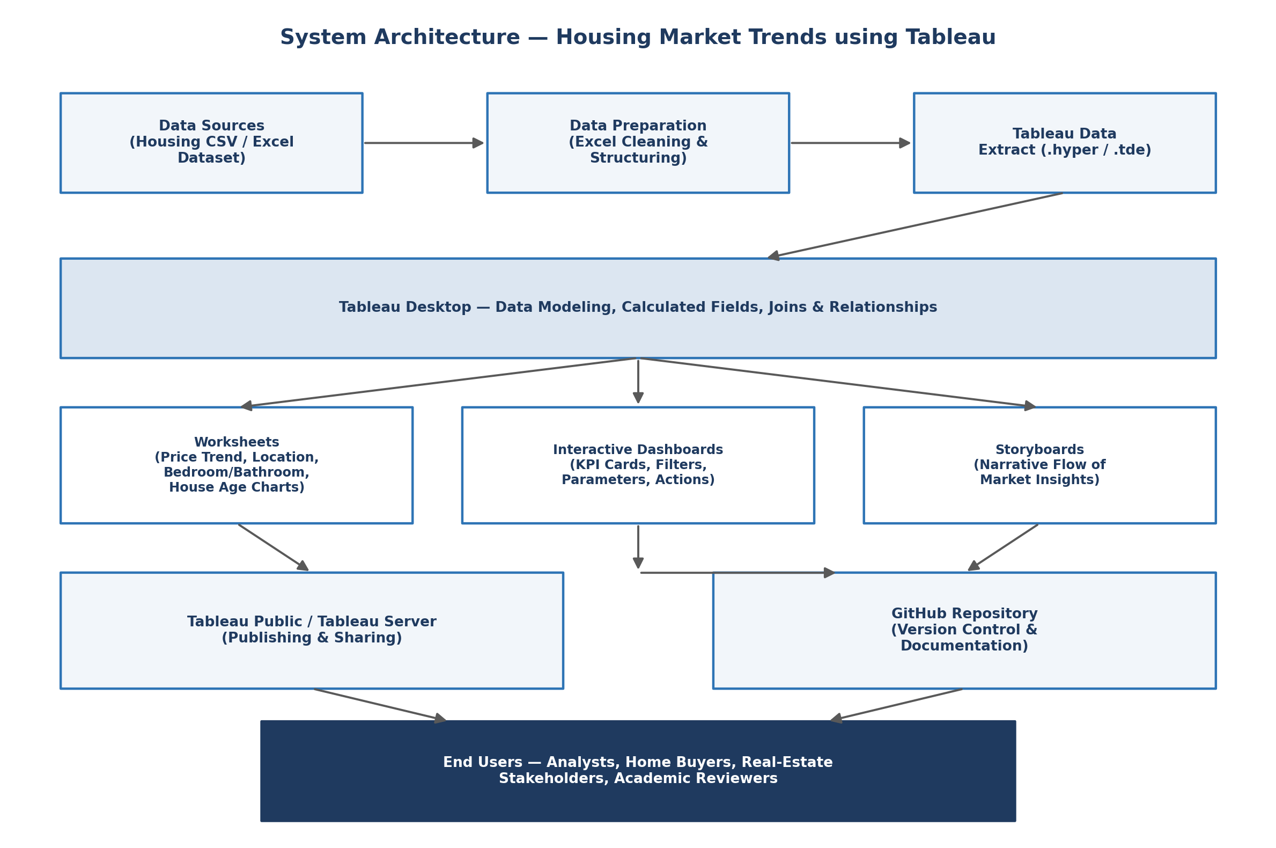
Figure 5.1: System Architecture Diagram
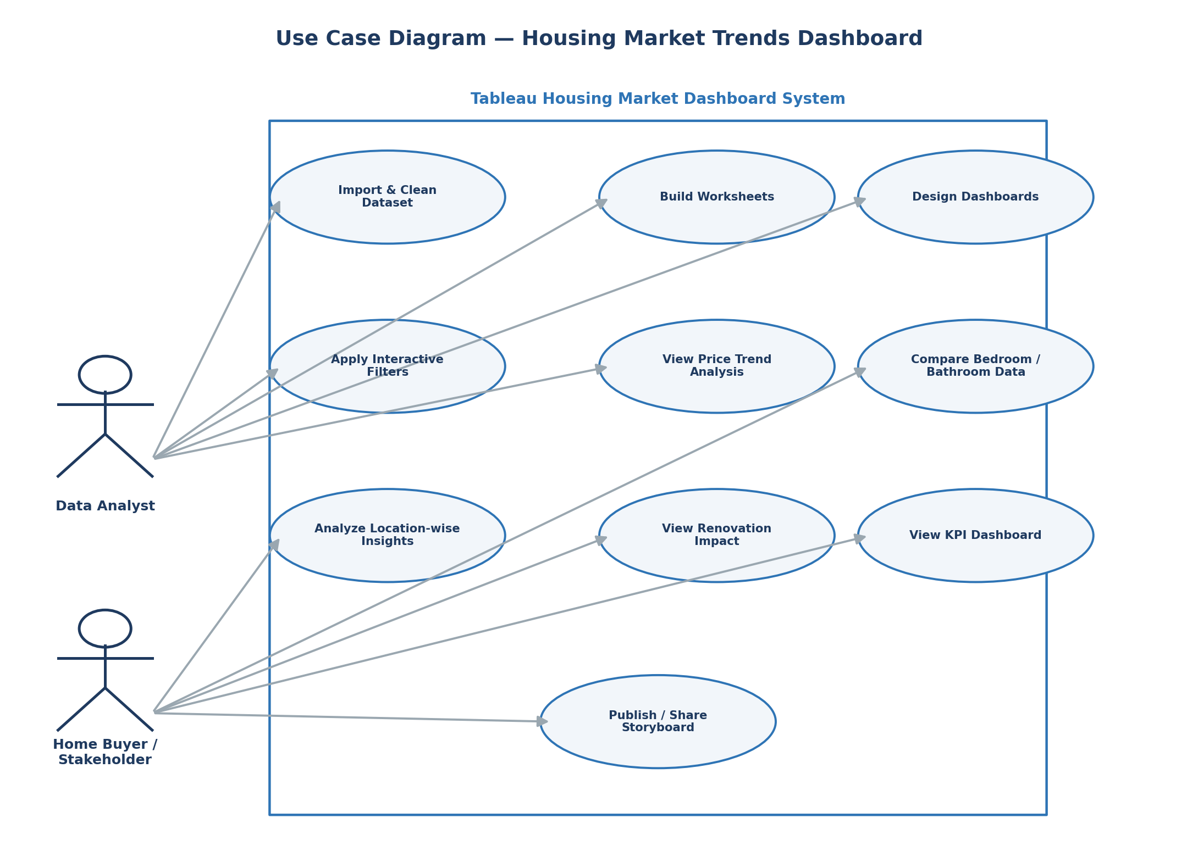
Figure 5.2: Use Case Diagram
6. Implementation & Actual Dashboard Output
The following screenshots were captured directly from the completed Tableau workbook.
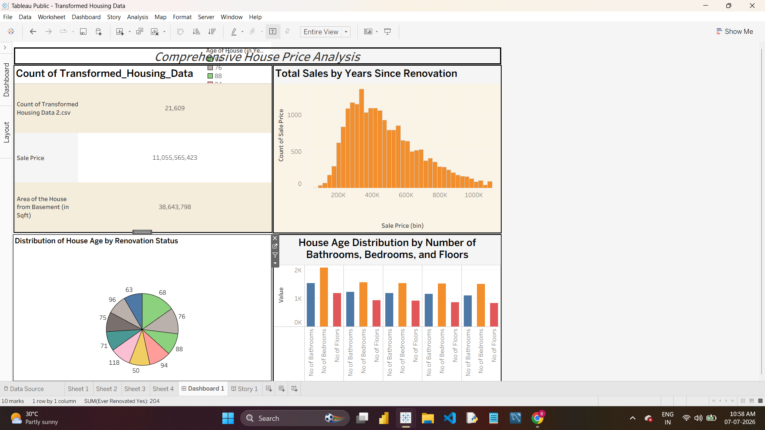
Figure 6.1: Dashboard 1 — Comprehensive House Price Analysis (actual build)
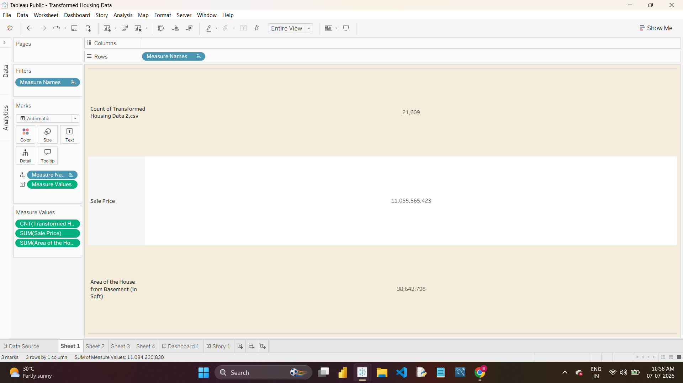
Figure 6.2: Sheet 1 — KPI Summary (actual build)
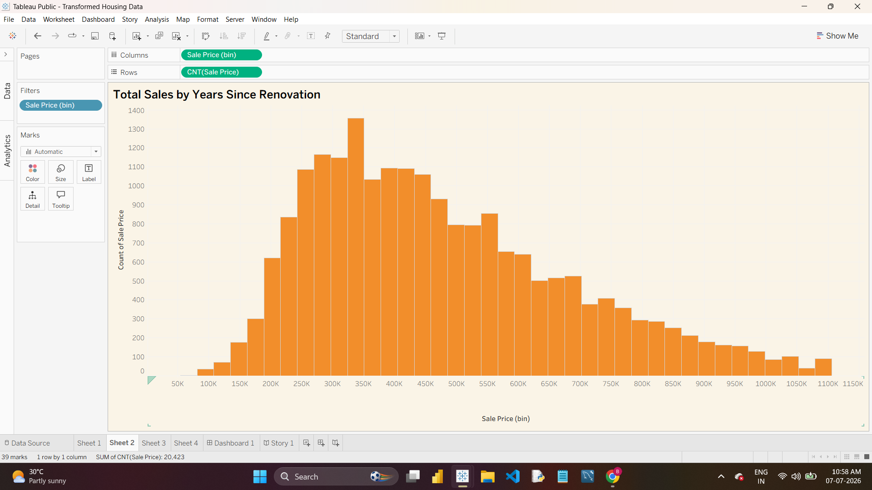
Figure 6.3: Sheet 2 — Sale Price Histogram (actual build)
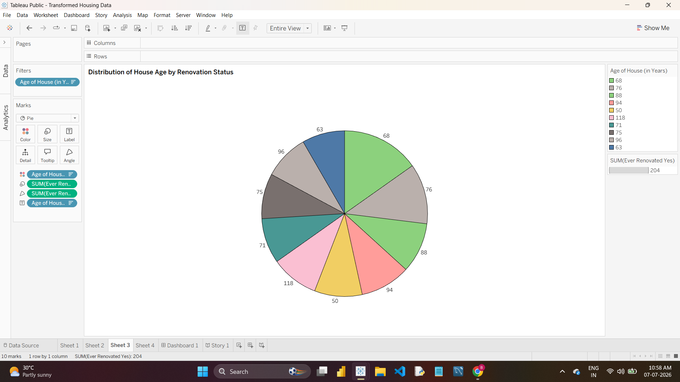
Figure 6.4: Sheet 3 — House Age by Renovation Status (actual build)
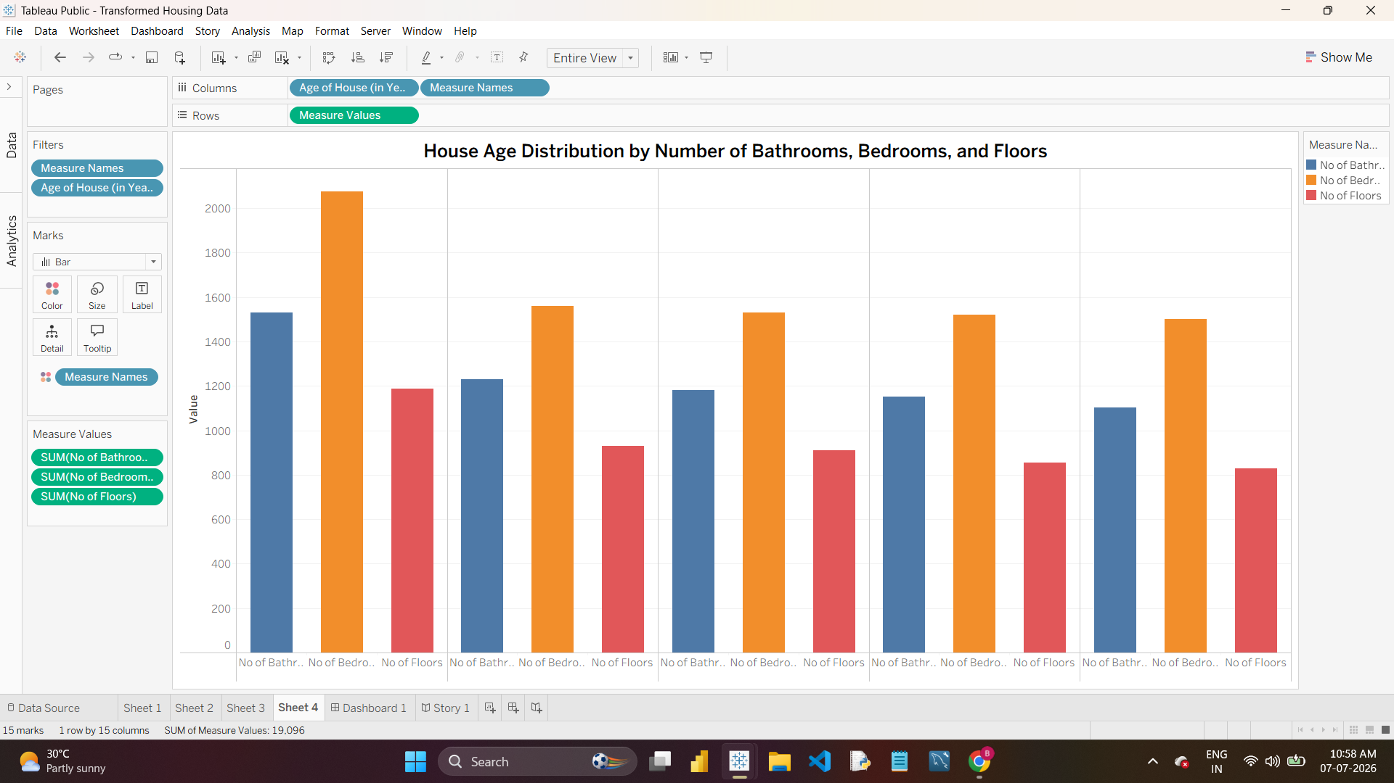
Figure 6.5: Sheet 4 — Feature Comparison by House Age (actual build)
Storyboard (Story 1)
A 5-point storyboard was built to narrate the dashboard's insights: Comprehensive House Price → Dashboard Highlights Key → The Sales Distribution → The Age of Houses Varies Based On → House Age Distribution Is.
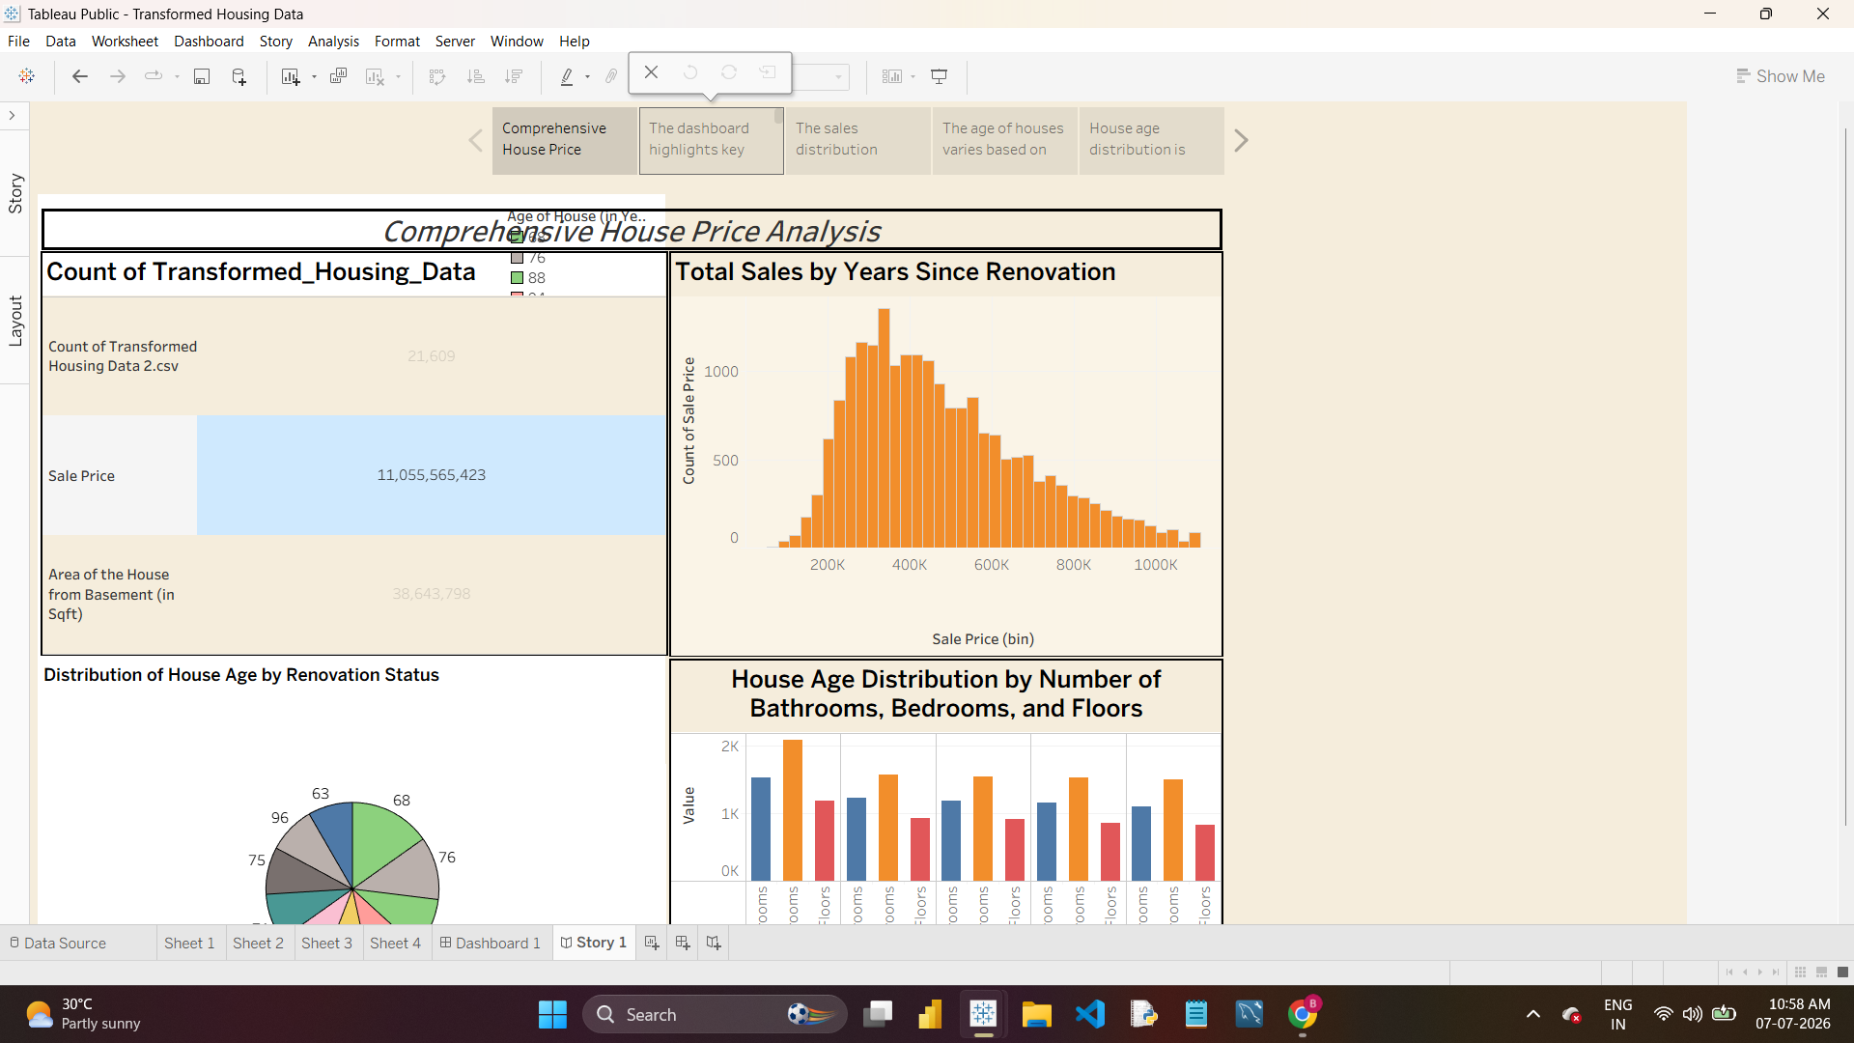
Figure 6.6: Story 1, Point 1 — Comprehensive House Price
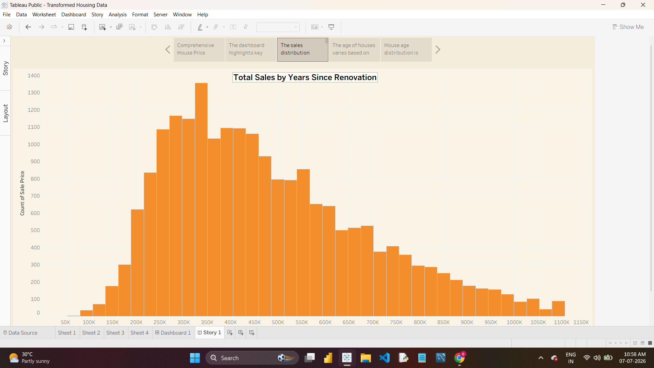
Figure 6.7: Story 1, Point 3 — The Sales Distribution
7. Testing
Performance testing and User Acceptance Testing were carried out on the workbook — see the Performance Testing and User Acceptance Testing documents in the Project Development Phase folder. All test cases passed, confirming the dashboard's accuracy, responsiveness, and usability.
8. Results & Discussion
The dashboard reveals that sale prices are concentrated between roughly 250K and 450K, with a long tail toward higher-value properties. House age is broadly distributed across the dataset with a meaningful share of properties having been renovated. Bedroom counts consistently exceed bathroom and floor counts across all house-age groupings, reflecting typical single/multi-bedroom family housing.
9. Conclusion
The project successfully demonstrates how Tableau can turn a transformed housing dataset into an accessible, interactive dashboard, enabling faster and more confident housing market analysis without any custom coding.
10. Future Scope
- Incorporate the latitude/longitude fields already present in the dataset into a geographic map view.
- Add predictive price estimation using Tableau forecasting.
- Extend the Zipcode Group fields into a detailed location-based comparison dashboard.
- Build a mobile-optimized layout for on-the-go research.
11. References
- Tableau Desktop Official Documentation — Tableau Software, LLC.
- Transformed_Housing_Data_2.csv — Project dataset.
- Project GitHub Repository — https://github.com/Bhavani-720/Housing-Market-Trends-Tableau

